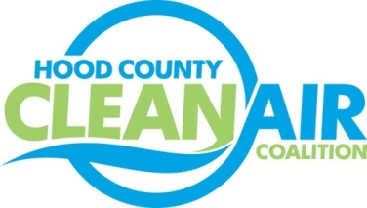
Meeting: Wednesday, January 6, 2015
American Town Hall
220 N. Travis Street, Granbury, Texas 76048
8:30-10:00 a.m.

Agenda

- Call Meeting to Order
- EPA Updates – Carrie Paige
- Regional Updates – Michelle McKenzie
  - Air Quality Funding Opportunities for Vehicles
    - Emission Reduction Incentive Grant
    - Clean Texas Triangle and Alternative Fueling Facilities Program
  - DFW Clean Cities Propane Subcommittee Meeting Monday, January 25th at 12 pm working lunch. More information at www.dfwcleancities.org.
  - Invitation for local governments to participate in idling working group meeting in Arlington on February 23rd from 1-3 pm.
- Local Updates – Michelle McKenzie
  - Review of December Meeting Summary
  - Review of Projects
    - Monthly Budget Review for November
    - Status of Projects FY 14/15
      - Surrey Bikes
      - Propane Refueling Stations
    - Starting Projects FY 16/17
  - HCCAC end of year update
  - HCCAC Officer Elections
5.) Discussion
6.) Adjourn

